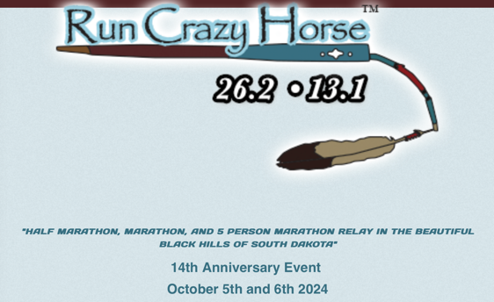

Please complete the registration below:

Name Email

Address

Phone Emergency Contact

I would like to participate in:

Half Marathon ($100)

Marathon ($110)

5-Person Marathon Relay ($275)

Fast 5K ($25)

Kids 1K ($10)

Please send registration and fee to:
Get Me Registered, 2024 Avenue of Chiefs, Crazy Horse SD 57730

Make checks payable to Run Crazy Horse (return by Oct 2)

